To create the React Project named movie-rater we have types the command as follows:

npx create-react-app movie-rater

cd movie-rater

code .

got to terminal type npm start

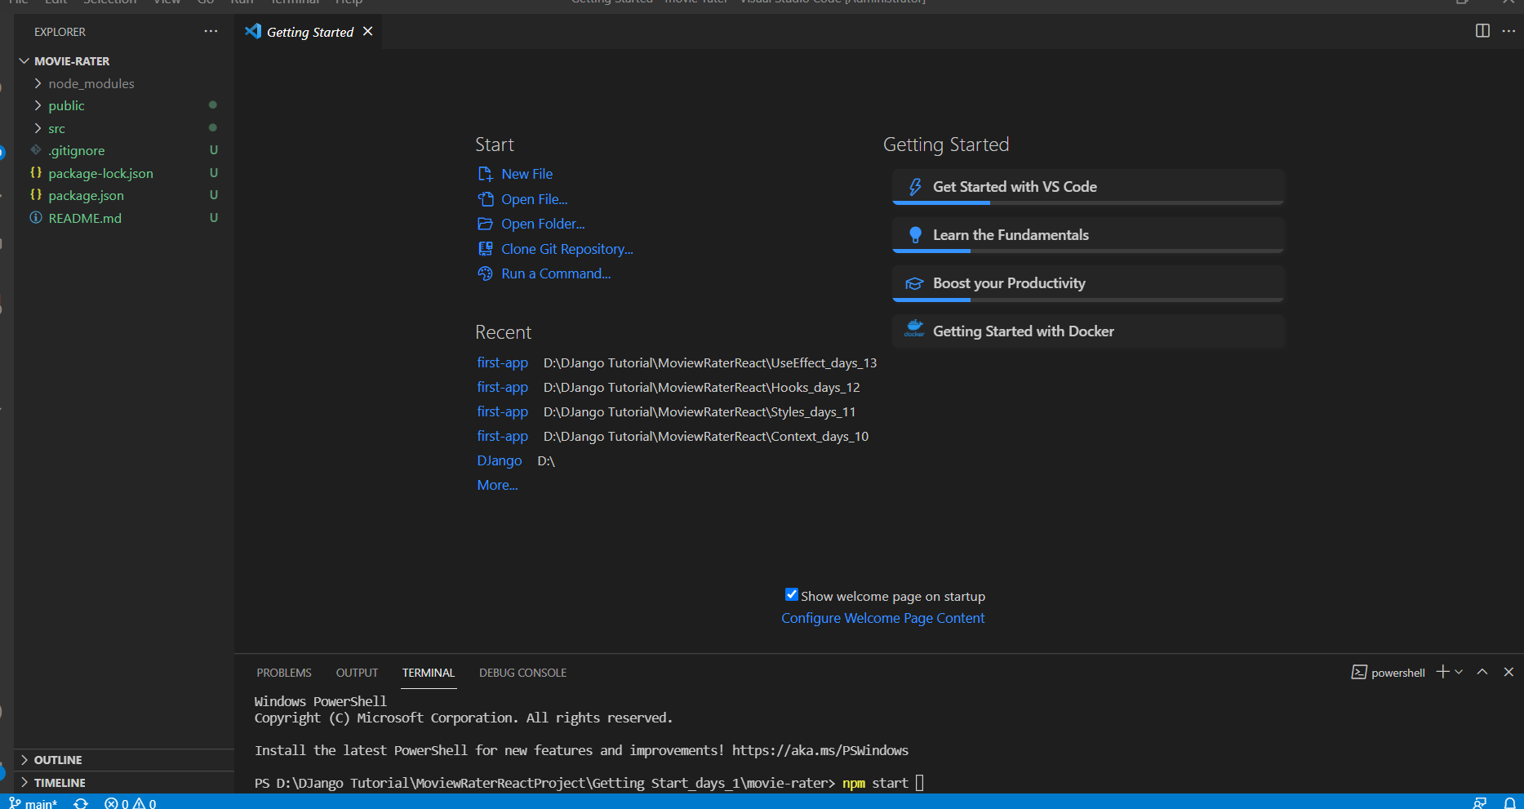

And the delete the logo.svg,App.test.js and setupTest.js

And Change the tiltle in index.html file located in public folder as follows:

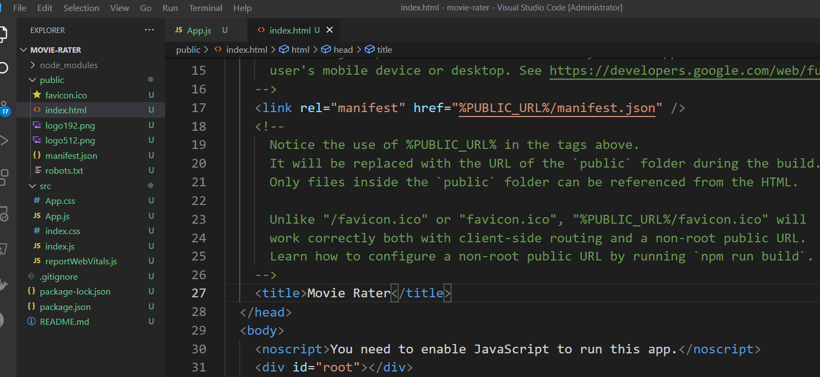

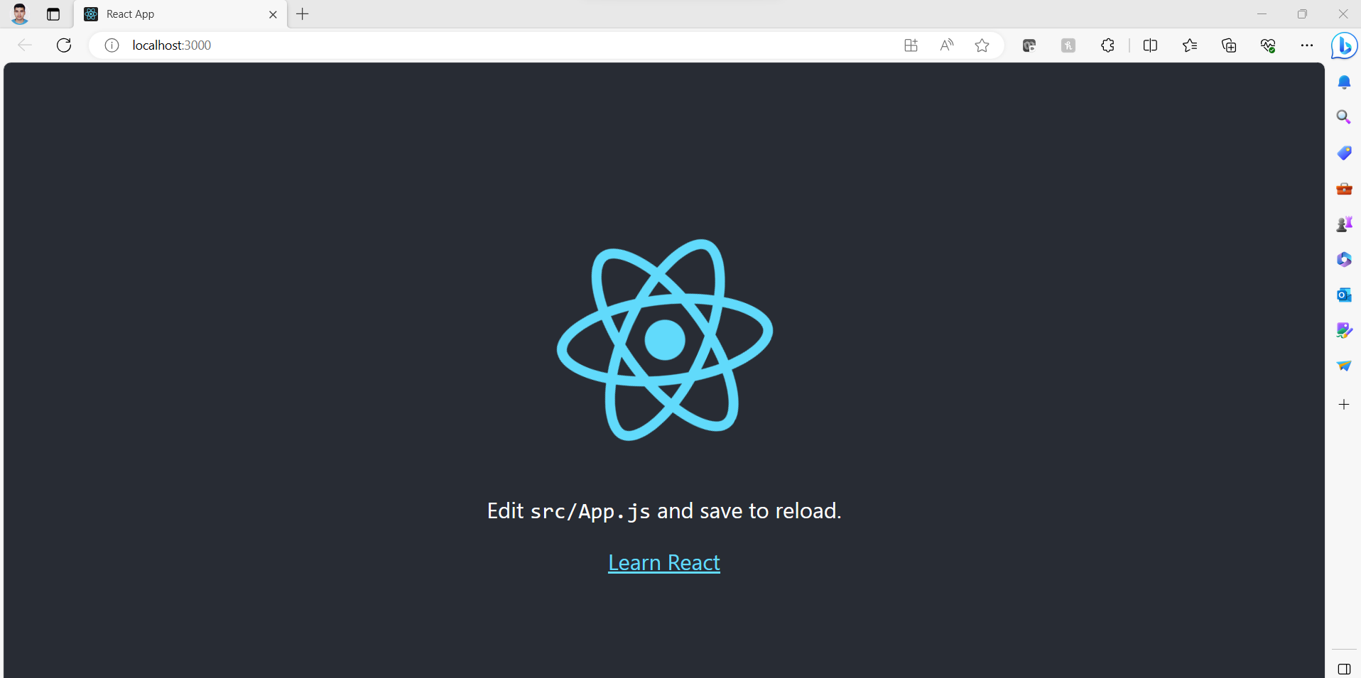

Open the App.js and remove the code as shown below :

//import logo from './logo.svg';

import './App.css';

function App() {

  return (

    <div className="App">

      <header className="App-header">

        {

        <h1> Moview Rater</h1>

        /* <img src={logo} className="App-logo" alt="logo" />

        <p>

          Edit <code>src/App.js</code> and save to reload.

        </p>

        <a

          className="App-link"

          href="https://reactjs.org"

          target="_blank"

          rel="noopener noreferrer"

        >

          Learn React

        </a> */}

      </header>

    </div>

  );

}

export default App;

If we want to change the logo of default react we have to change the fabicon.ico file

Modify the App.css located in src folder as follows:

